**毕业生线上采集照片**

**Online taking photos**

**of the graduates**

**使用手册**

**User Manual**

2018 企业产品宣传画册模板

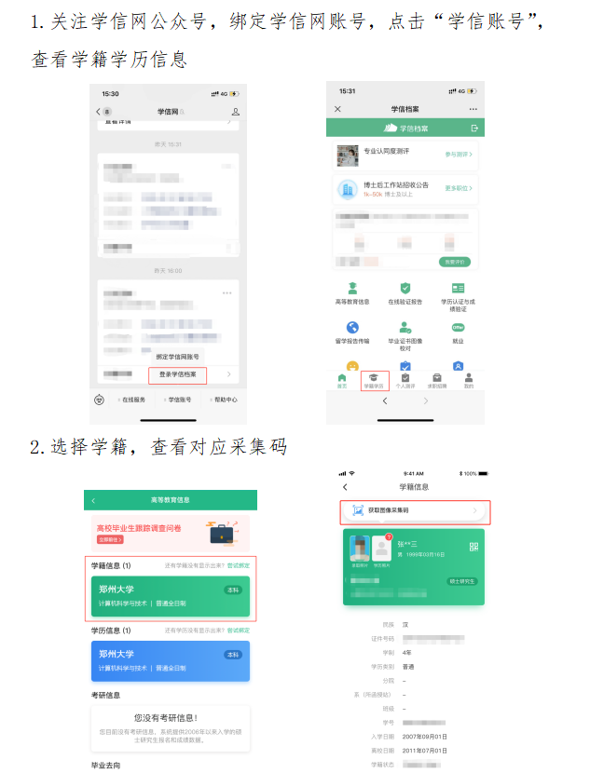

Click the information of school roll and check the collection code of photos.

1. Follow the WeChat official account of chsi; bind your account; click the account and check your information of school roll and education qualifications.

·图像采集码获取方式The acquisition method of the collection code

**使用步骤**

**Steps**

·获取到图像采集码后

After getting the collection code of photos,

·可扫描下方的二维码创建拍摄账号

You can scan the QR code below to create a photo account.



**使用步骤**

**steps**

**使用步骤**

**Steps**

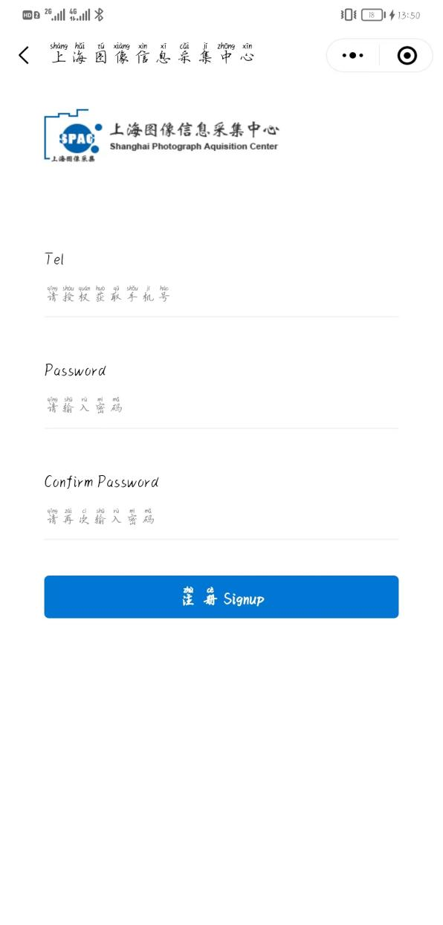

For new users, please directly click "First Use".

·选择登录状态Select the login status

·新用户点击“第一次使用”。

For new users, please click "First Use".

·创建拍摄账号。

Create a photo account

（手机号码要真实有效）

The phone number must be true and effective.

**使用步骤**

**Steps**

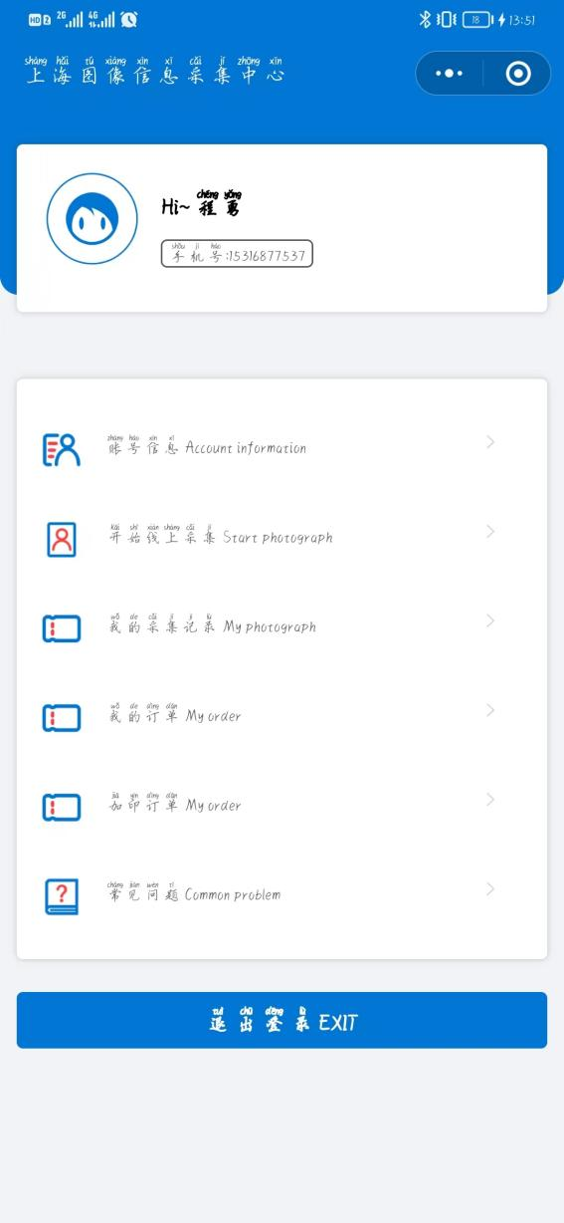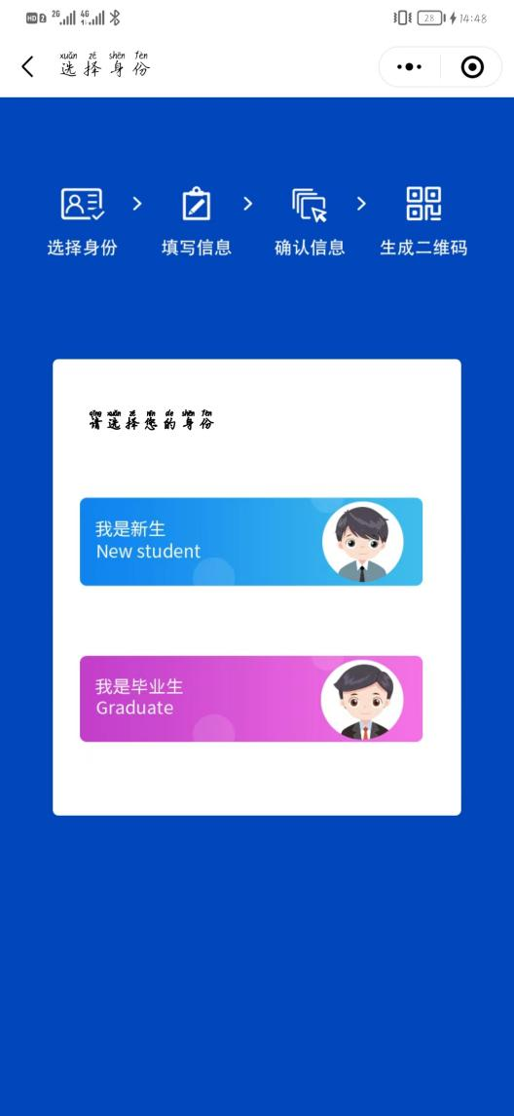

·点击“开始线上采集”。

Click "Start Online Collection"

·点击“我是毕业生”。

Click "Graduate"

**使用步骤**

**Steps**

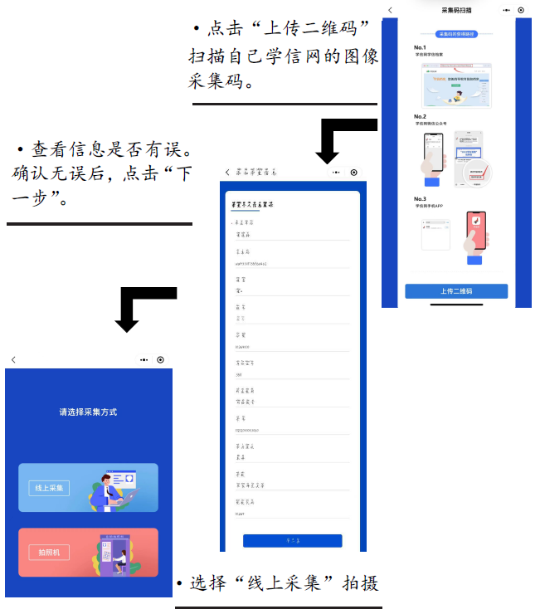

Select “Online collection” and take photos.

Click “upload the collection QR code” and scan the collection QR code.

Check personal information. Make sure there is no mistake. Then click “the next step”.

**使用步骤**

**Steps**

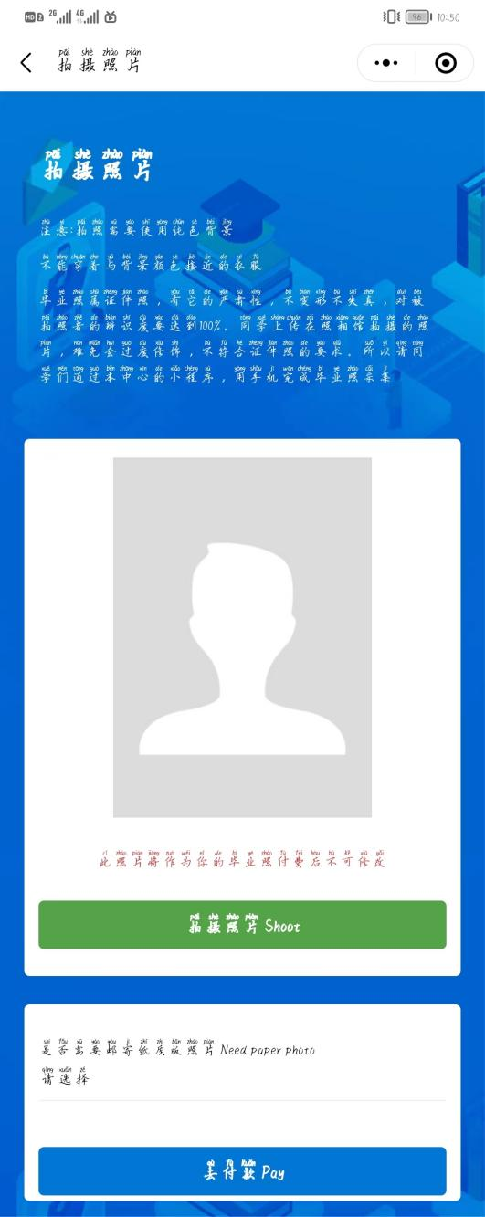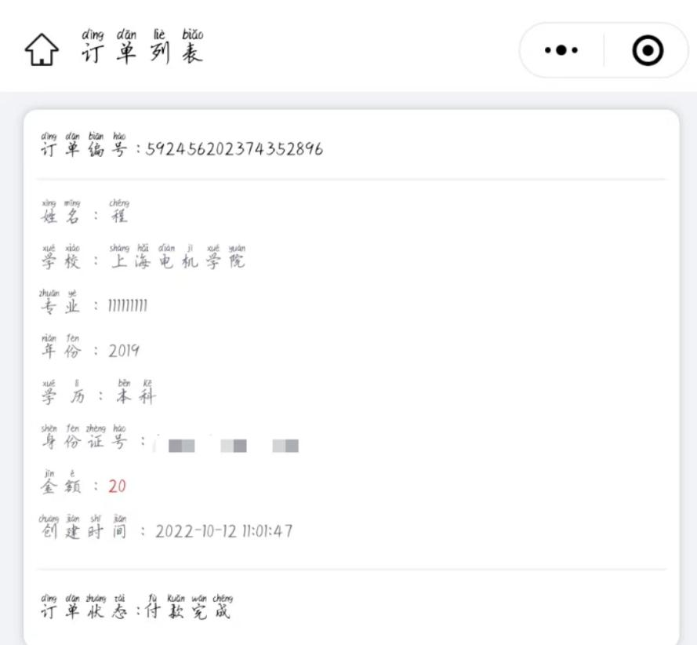

·有照片需求的同学可以选择加印照片，会以寄快递方式寄出。没有照片需求的同学可选择不需要If you need paper photos, you can choose to print them and receive by express. Those who don't need a photo can choose “No photos required”.

·订单状态显示付款完成后，才完成拍摄。

When the order status shows that the payment is completed, the whole process is end.

·点击“拍摄照片”

Click "Shoot" on the screen

（仔细看提示七步骤，往左滑。）Look carefully at the seven steps in the tips, and slide left to the next page.